AI CV Tailoring Platform – Frontend Product Requirements

Overview
This document defines the frontend user journey and product requirements for the AI CV Tailoring and Cover Letter Platform. It translates the product vision into a clear, implementable description of user flows, page structures, and key interactions that complement the backend architecture already defined in the implementation pack.
The frontend product is designed to guide users through a seamless experience: from landing on the homepage, to testing the CV matching engine for free, to unlocking premium features like cover letter generation and company job alerts through a paywall.

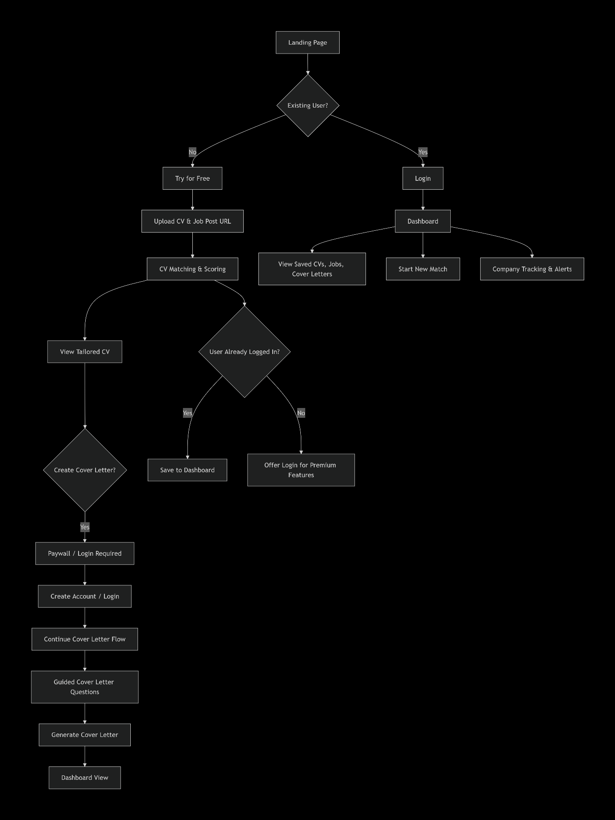
User Personas

New User (Anonymous)
- Lands on the homepage
- Can "Try for Free" without creating an account
- Uploads one CV and one job post for matching
- Receives a score and tailored CV
- Must create account to access cover letter and premium features

New User (Registered)
- Creates account during or after the free trial
- Saves CVs, jobs, and cover letters to dashboard
- Has access to premium features after payment

Returning User
- Logs in to dashboard
- Sees history of CVs, jobs, and cover letters
- Can run new matches, track companies, and receive job alerts

Premium User
- Has paid subscription
- Access to unlimited CV tailoring, cover letters, and company tracking
- Receives job alerts

Page-by-Page Breakdown

1. Landing Page (Homepage)
Purpose: First impression. Drive users to try the product or log in.
Structure:
Section | Content
Navigation | Logo, "Try for Free" (CTA), "Login"
Hero Section | Headline: "Tailor Your CV to Any Job in Seconds"  Sub-headline: "AI-powered CV matching and tailoring—get past ATS and land more interviews"  CTA: "Try for Free"
Features Section | 3–4 feature cards:  • ATS Score & Readiness Check  • Smart CV Rewriting  • Guided Cover Letter Generation  • Job Tracking & Alerts
How It Works | 3-step visual flow:  1. Upload CV & Job Link  2. AI Matches & Scores  3. Download Tailored CV
Social Proof | Testimonials, trust badges, logos (if available)
Footer | Links, contact, legal
Design Notes:
- Clean, professional, modern
- Trust-focused (show security badges)
- Strong visual hierarchy with clear CTA

2. Free Trial Page (CV & Job Upload)
Purpose: Onboard new users through the matching process without requiring account creation.
URL: /try
┌─────────────────────────────────────────────┐
│ ← Back │
│ Try for Free – No account required │
├─────────────────────────────────────────────┤
│ Step 1 of 3 │
│ │
│ 📄 Upload Your CV │
│ ┌────────────────────────────────────────┐ │
│ │ Drag & drop or click to upload │ │
│ │ Supports PDF, DOCX (max 10MB) │ │
│ └────────────────────────────────────────┘ │
│ [file name] ✅ Uploaded │
│ │
│ 🔗 Add the Job Post │
│ ┌────────────────────────────────────────┐ │
│ │ Paste job description URL or text │ │
│ └────────────────────────────────────────┘ │
│ [✓] I have the job description ready │
│ │
│ [ Analyze My CV ] │
├─────────────────────────────────────────────┤
│ 🔒 Your data is encrypted and private │
└─────────────────────────────────────────────┘
User Actions:
- Upload CV (PDF or DOCX)
- Provide job post (URL or pasted text)
- Click "Analyze My CV"
Technical Notes:
- No authentication required at this stage
- Uploads are stored temporarily with a session ID
- Backend endpoints: POST /cvs, POST /job-posts/url or /job-posts/text

3. CV Scoring & Results Page
Purpose: Display the match score, ATS readiness, and a detailed breakdown of how the CV performs against the job post.
URL: /results/{sessionId}
Page Elements:
┌─────────────────────────────────────────────────────────┐
│ 📊 Your CV Match Score │
│ │
│ ┌─────────────┐ │
│ │ 78% Match │ ⭐ Good match! │
│ │ (vs. job) │ │
│ └─────────────┘ │
│ │
│ ════════════════════════════════════════════════════ │
│ │
│ 🔍 How you compare: │
│ │
│ ┌─────────────────────────────────────────────────────┐│
│ │ ✅ Skills Match 8/10 skills found ││
│ │ Python, AWS, Docker... ││
│ ├─────────────────────────────────────────────────────┤│
│ │ ⚠️ Experience Gap 2 key requirements missing ││
│ │ Kubernetes, Terraform ││
│ ├─────────────────────────────────────────────────────┤│
│ │ 💡 ATS Readiness High ││
│ │ Formatting, keywords, structure are good ││
│ └─────────────────────────────────────────────────────┘│
│ │
│ ✏️ Suggested CV Changes │
│ ┌─────────────────────────────────────────────────────┐│
│ │ "Led team of 5 engineers" → "Led and mentored team"││
│ │ "Implemented microservices" → "Designed AWS-based" ││
│ │ [Show All Suggestions] ││
│ └─────────────────────────────────────────────────────┘│
│ │
│ [ View My Tailored CV ] ⭐ Download Free │
│ │
│ [ Create Cover Letter ] 🔒 Requires Login │
│ │
│ ──────────────────────────────────────────────────── │
│ 💡 Tip: Create an account to save your CVs and jobs │
└─────────────────────────────────────────────────────────┘
Visual Elements:
- Score gauge (circular or horizontal bar)
- Color coding: Green (75%+), Amber (50–74%), Red (<50%)
- Expandable suggestion cards
- Two primary CTAs:
  - "View My Tailored CV" → Downloads the generated CV (free)
  - "Create Cover Letter" → Triggers login/paywall flow
Technical Notes:
- Data from backend: GET /matches/{matchId} and GET /tailored-cvs/{draftId}
- Session ID stored in browser (cookie or localStorage)
- "View My Tailored CV" is free; cover letter is gated

4. Login & Registration Flow
Purpose: Seamless authentication with context preservation (user doesn't lose progress).
Trigger Points:
- Clicking "Create Cover Letter" from results page
- Clicking "Login" from navigation
- Trying to access premium features
Flow Options:

Option A: Modal Overlay (Recommended)
┌─────────────────────────────────────────────────────────┐
│ ✕ │
│ │
│ 🔒 Create an account to continue │
│ │
│ "You're about to create a cover letter for the Senior │
│ Software Engineer role at TechCorp" │
│ │
│ ┌─────────────────────────────────────────────────────┐ │
│ │ Email │ │
│ └─────────────────────────────────────────────────────┘ │
│ ┌─────────────────────────────────────────────────────┐ │
│ │ Password │ │
│ └─────────────────────────────────────────────────────┘ │
│ ┌─────────────────────────────────────────────────────┐ │
│ │ Confirm Password │ │
│ └─────────────────────────────────────────────────────┘ │
│ │
│ [ Create Account & Continue ] │
│ │
│ Already have an account? [Log In] │

└─────────────────────────────────────────────────────────┘
Option B: Dedicated Page
text
/login or /register page with clear redirect back to workflow
Context Preservation:
- Store session ID, CV ID, and job post ID
- After authentication, redirect to /cover-letter/{workflowId} or /dashboard
- User picks up exactly where they left off
User Management Options:
- Supabase (recommended): Built-in auth, PostgreSQL, real-time, easy integration
- Firebase: Good alternative with Auth, Firestore, and storage
- Custom JWT-based: We already defined this in the backend—can use it with a simple frontend auth service
Recommendation: Use Supabase for user management. It integrates well with the existing PostgreSQL schema and provides Auth, Row Level Security (RLS), and real-time features out of the box.

5. Guided Cover Letter Workflow
Purpose: Interactive, step-by-step cover letter creation using the user's CV and job post, with follow-up questions to fill gaps.
URL: /cover-letter/{workflowId} (authenticated only)
Page Elements:
┌─────────────────────────────────────────────────────────┐
│ ← Dashboard | Cover Letter Generator │
├─────────────────────────────────────────────────────────┤
│ Step 2 of 4 │
│ 📝 Tell us more about your experience │
│ │
│ ┌─────────────────────────────────────────────────────┐│
│ │ Question: ││
│ │ "Please provide a specific achievement that ││
│ │ demonstrates your AWS expertise" ││
│ │ ││
│ │ ┌─────────────────────────────────────────────┐ ││
│ │ │ (Text area) │ ││
│ │ │ │ ││
│ │ └─────────────────────────────────────────────┘ ││
│ │ ││
│ │ 💡 Tip: This will be used to strengthen ││
│ │ your cover letter. Be specific. ││
│ └─────────────────────────────────────────────────────┘│
│ │
│ [ Skip ] [ Next → ] │
│ │
│ ─── Progress: ●●●○ ─── │
└─────────────────────────────────────────────────────────┘
Step Progression:
- Step 1: Motivation & fit for the role
- Step 2: Specific achievements & evidence
- Step 3: Tone, availability, and preferences
- Step 4: Review draft and finalise
Technical Notes:
- Backend endpoints: POST /cover-letters/start, GET /cover-letters/{workflowId}/questions, POST /cover-letters/{workflowId}/answers
- Progress bar indicates completion
- Answers saved; can skip non-required questions
- After all steps, draft is generated: GET /cover-letters/{workflowId}/draft

6. User Dashboard
Purpose: Central hub for all user activities—CVs, job posts, cover letters, and company tracking.
URL: /dashboard
Layout:
┌──────────────────────────────────────────────────────────────────────┐
│ 👋 Welcome, Jane [Upgrade to Premium] [Logout] │
├──────────────────────────────────────────────────────────────────────┤
│ │
│ 📊 Quick Stats │
│ ┌────────────┬────────────┬────────────┬──────────────────────┐ │
│ │ CVs: 5 │ Jobs: 12 │ Letters: 3 │ Companies: 4 │ │
│ └────────────┴────────────┴────────────┴──────────────────────┘ │
│ │
│ ────────────────────────────────────────────────────────────────── │
│ │
│ 📄 Recent CVs [+ New CV] │
│ ┌─────────────────────────────────────────────────────────────────┐│
│ │ Senior Software Engineer | TechCorp | Match: 78% | ✓ ││
│ │ Product Designer | DesignCo | Match: 65% | ✓ ││
│ │ Data Analyst | DataCorp | Match: 92% | ✓ ││
│ └─────────────────────────────────────────────────────────────────┘│
│ │
│ 💼 Recent Jobs [+ New Job] │
│ ┌─────────────────────────────────────────────────────────────────┐│
│ │ Senior Software Engineer | TechCorp | 📅 2026-08-01 ││
│ │ Product Designer | DesignCo | 📅 2026-07-28 ││
│ └─────────────────────────────────────────────────────────────────┘│
│ │
│ 💌 Recent Cover Letters [+ New Cover Letter] │
│ ┌─────────────────────────────────────────────────────────────────┐│
│ │ Senior Software Engineer | TechCorp | Draft ready ││
│ └─────────────────────────────────────────────────────────────────┘│
│ │
│ ────────────────────────────────────────────────────────────────── │
│ │
│ 🏢 Company Tracking (Premium) [+ Track Company] │
│ ┌─────────────────────────────────────────────────────────────────┐│
│ │ Amazon | Product Design | 🔔 New jobs: 2 | Manage ││
│ │ Google | Product Design | 🔔 New jobs: 0 | Manage ││
│ │ Facebook | Product Design | 🔔 New jobs: 1 | Manage ││
│ └─────────────────────────────────────────────────────────────────┘│
│ │
│ [🔒 Upgrade to Premium to track unlimited companies] │
└──────────────────────────────────────────────────────────────────────┘
Dashboard Features:
Section | Purpose
Quick Stats | Summary of user's activity
Recent CVs | List of uploaded CVs with match scores
Recent Jobs | List of job posts with dates
Recent Cover Letters | List of generated cover letters
Company Tracking | Premium feature; follows companies for job alerts
Technical Notes:
- Backend endpoints: GET /cvs, GET /job-posts, GET /cover-letters/{workflowId}/draft
- Company tracking: custom implementation with subscription model
- Dashboard data fetched on load

7. Company Tracking & Job Alerts (Premium Feature)
Purpose: Allow users to follow companies and receive notifications when relevant jobs are posted.
User Flow:
┌─────────────────────────────────────────────────────────────┐
│ 🏢 Track Companies │
├─────────────────────────────────────────────────────────────┤
│ Search: [________________________________] [Search] │
│ │
│ Company Name | Industry | Status | Actions │
│ ────────────────|──────────────|───────────|──────────────│
│ Amazon | E-commerce | 🟢 Active | [Unfollow] │
│ Google | Technology | 🟢 Active | [Unfollow] │
│ Facebook | Social Media | 🔴 Inactive| [Reactivate]│
│ │
│ [ + Track New Company ] │
│ │
│ ───────────────────────────────────────────────────────── │
│ 🔔 Recent Alerts │
│ ┌─────────────────────────────────────────────────────────┐│
│ │ Amazon: New Senior Product Designer role (2026-08-02) ││
│ │ Facebook: New UX Researcher role (2026-07-30) ││
│ └─────────────────────────────────────────────────────────┘│
Technical Considerations:
- Company data from public API (e.g., LinkedIn, Glassdoor, or custom scraper)
- Industry matching: can be keyword-based or ML
- Notifications: email (SendGrid) and in-app notifications
- Premium feature: gated behind subscription

Frontend Technology Stack

Recommended Stack
Layer | Technology | Justification
Framework | Next.js 14+ (App Router) | Full-stack React with SSR/SSG, API routes, and great developer experience
UI Library | React 18+ | Component-based architecture
Styling | Tailwind CSS | Utility-first, fast development, consistent design
Component Library | shadcn/ui | Accessible, customisable components matching the design
State Management | Zustand or Context API | Lightweight for user session, upload state, and form data
Authentication | Supabase Auth (or NextAuth.js) | Built-in social login, email/password, session management
Forms | React Hook Form + Zod | Type-safe form validation
File Upload | react-dropzone | Drag-and-drop file upload with validation
Charts/Visuals | Recharts or Chart.js | Score gauges, match visualisations
Notifications | react-hot-toast | In-app toast notifications
PDF Generation | react-pdf | PDF generation and preview
API Client | TanStack Query (React Query) | Caching, revalidation, and state management for API calls

Folder Structure (Frontend)
text
frontend/
├── app/
│ ├── (auth)/
│ │ ├── login/
│ │ ├── register/
│ │ └── layout.tsx
│ ├── (dashboard)/
│ │ ├── dashboard/
│ │ ├── cvs/
│ │ ├── jobs/
│ │ ├── cover-letters/
│ │ ├── company-tracking/
│ │ └── layout.tsx
│ ├── try/
│ │ ├── upload/
│ │ ├── results/
│ │ └── page.tsx
│ ├── cover-letter/
│ │ └── [workflowId]/
│ ├── api/
│ │ └── ... (Next.js API routes or external)
│ ├── layout.tsx
│ └── page.tsx
├── components/
│ ├── ui/ (shadcn components)
│ ├── forms/
│ ├── dashboard/
│ ├── results/
│ ├── cover-letter/
│ └── shared/
├── lib/
│ ├── api/
│ ├── auth/
│ ├── validations/
│ └── utils/
├── hooks/
├── types/
├── styles/
└── public/

Frontend-Backend Integration

Key Integration Points
Frontend Action | Backend Endpoint | Response
Upload CV | POST /cvs | cvId, jobId
Submit Job Post (URL) | POST /job-posts/url | jobPostId
Submit Job Post (Text) | POST /job-posts/text | jobPostId
Create Match | POST /matches | matchId
Get Match Results | GET /matches/{matchId} | Match data, score, coverage
Get Tailored CV | GET /tailored-cvs/{draftId} | Draft content
Download Tailored CV | POST /exports/cv/{draftId} | File URL
Start Cover Letter | POST /cover-letters/start | workflowId, questions
Submit Cover Letter Answers | POST /cover-letters/{workflowId}/answers | Next questions
Get Cover Letter Draft | GET /cover-letters/{workflowId}/draft | Draft content
Download Cover Letter | POST /exports/cover-letter/{workflowId} | File URL
Login/Register | POST /auth/login, /auth/register | User + token
Get Dashboard Data | GET /cvs, /job-posts | Lists of CVs and jobs

State Management
Session State:
- User authentication: Supabase session
- CV upload ID: Stored in localStorage or URL params
- Job post ID: Stored in localStorage or URL params
- Match ID: Stored in URL params for sharing

User Flow State (for unauthenticated users):
{

sessionId: "temp_session_123",

cvId: "cv_uuid",

jobPostId: "job_uuid",

matchId: "match_uuid",

draftId: "draft_uuid",

workflowId: "workflow_uuid",

currentStep: 1

}
Error Handling
Scenario | Frontend Handling
API 4xx/5xx | Show friendly error toast; log to console
Network offline | Show offline indicator; retry with exponential backoff
Upload failure | Show error with retry option
Authentication expiry | Redirect to login with return URL
Rate limit exceeded | Show cooldown timer; encourage upgrade

Design Considerations

Figma to be provided by ux/ui designer
Performance
- Lazy load heavy components (charts, PDF preview)
- Use Next.js Image optimisation for static assets
- Cache API responses with React Query
- Implement skeleton loaders for dashboard data

Accessibility (A11y)
- ARIA labels on interactive elements
- Keyboard navigable
- High contrast mode support
- Screen reader friendly

Branding & Theme

Will be provided along with the Figma design
Future Expansion Roadmap
Phase | Feature
Phase 1 (MVP) | CV upload, job post match, scoring, tailored CV download
Phase 2 (Launch) | Cover letter generation, login/register, dashboard
Phase 3 (Growth) | Company tracking, job alerts, premium subscriptions
Phase 4 (Scale) | Multi-language, team collaboration, recruiter tools

Appendix: Key User Journeys Summary

Journey 1: New User – Try for Free
- Land on homepage → click "Try for Free"
- Upload CV + job post → click "Analyze My CV"
- See match score and suggestions → click "View Tailored CV"
- Download CV (free)
- Click "Create Cover Letter" → prompted to login/register
- Create account → continue to cover letter flow

Journey 2: Returning User – New Match
- Log in → dashboard
- Click "New CV" → upload + job post
- Match analysis → click "View Tailored CV"
- Download CV
- Create cover letter (if premium) → guided flow → download letter

Journey 3: Premium User – Company Tracking
- Dashboard → "Track Companies"
- Search and add companies
- Set industry/keywords
- Receive notifications (email/in-app)
- Apply to new jobs directly from notification

